Canterbury Bankstown Council

PROPOSED DOUBLE BRICK VENEER DWELLING

IN RESPECT OF
Lot 4, 57 Tompson Road PANANIA 2213
DP: 16499

FOR
Mr & Mrs Phipps C/O WISDOM HOMES

STATEMENT OF ENVIRONMENTAL EFFECTS



17-19 Central Hills Drive Gregory Hills NSW 2557
Phone: 1300 855 775 Fax: 02 4647 1233

INTRODUCTION
This document comprises a Statement of Environmental Effects to accompany a Development Application to undertake the construction of a double story brick veneer dwelling.

SITE & SURROUNDING LOCALITY

The subject site is bounded by a frontage to Tompson Road of 12.191 metres, an Western boundary of 62.370 metres, and a Eastern boundary of 62.380 metres and an Southern (rear) boundary of 12.190 metres comprising a total area of 758.80m².

The locality is a newly developed residential site which will be maintained for the proposed development.
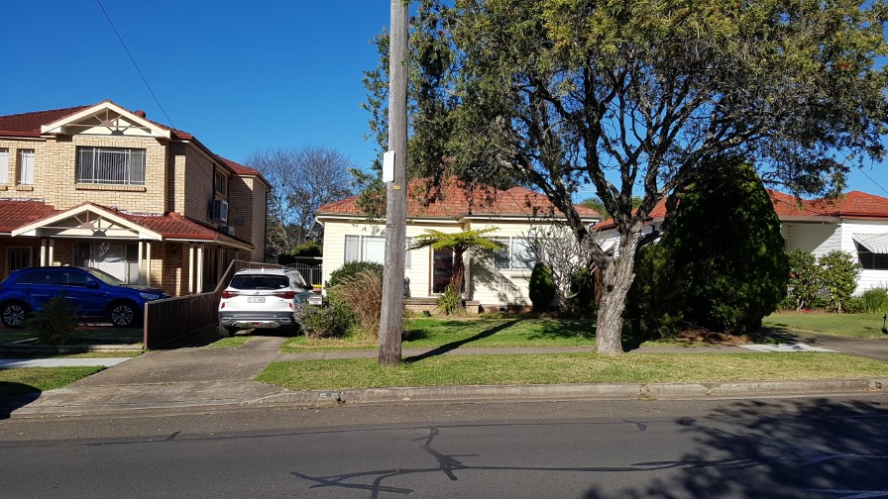
DESIGN GUIDELINES (DCP)
The proposal is for a double storey brick veneer dwelling with selected Colourbond roof. The proposed residence will have a front setback of 6.5 metres, and a rear setback of 34.707 metres. The side setbacks of the proposed development will be a minimum of 0.921mm to the East side and 0.920mm to the West side of the property.

The proposed dwelling will consist of:
- Garage
- 4 Bedrooms (inclusive of Master Suite with Ensuite)
- Kitchen
- Leisure Area
- Dining Area
- Main Bathroom
- Laundry
- Powder Room
- Outdoor Leisure
- Home Office
- Lounge

The floor area for the main dwelling is:
- Ground Floor = 119.40m²
- First Floor Living = 125.95m²
- Porch = 5.08m²
- Garage = 34.46m²
- Outdoor Leisure = 19.14m²

The total floor area for the proposed dwelling, including Garage, Porch & Outdoor Leisure = 304.03m².

The proposed residence will be a Wisdom Homes Washington 33 – a design which will be adapted to the future surroundings and character in the Panania area.

The home is designed with style and character through the use of articulation to the external walls as well as variations to the roof, with the design minimizing the bulk and scale of our proposed development.

The overall appearance of our proposal is in keeping with Canterbury/Bankstown Council DCP - Objectives and Development Control.

IMPACTS OF THE DEVELOPMENT
The proposal has no social or economic impact to the locality. Given the quality of the design the dwelling and proposed landscaping will have minimal impact on the existing streetscape other than to enhance the vision of the community.

The slab on ground construction will result in minimal disturbance to the natural slope of the subject land. Stormwater will be conveyed to the proposed rainwater tank located to the Eastern side of the proposed dwelling with the overflow discharged to the street, in which satisfies Council’s requirements.

COMPLIANCE WITH DEVELOPMENT STANDARDS
The premises is situated in an area zoned Residential (2) under Canterbury Bankstown City Council’s LEP. The construction of a dwelling is permissible in this zoning, with Council’s consent.

Compliance with the relevant DCP is summarized in the following table: -
Issue | Council | Proposed | Comment
 | Requirements (Min)
Front Setback (m) | 5.5m LOWER  6.5m UPPER | 6.5m | Complies
Side Setback (m) | 900mm | LHS 0.92m  RHS 0.92m | Complies
Rear Setback (m) | N/A | 34.70m LOWER  39.20 UPPER | Complies
Car Space | 2 off street parking | Double garage/driveway | Complies
Cut & Fill | 500mm max cut & 600mm fill | 130mm cut & 130mm fill | Complies
Stormwater | To water tank, overflow | To water tank. O/flow | Complies
Disposal | Subject to site | As per Hydraulic eng. | Complies
Solar Access | Sitting to maximise | Solar access maximised | Complies
 | solar access |  | Complies
Driveway Grade | Maximum 25% | Approx. 5.4% | Complies
Height Limit | Max. 2 Storey | 2 Storey | Complies

ECOLOGICAL SUSTAINABLE DEVELOPMENT
The proposal demonstrates cross flow ventilation throughout the dwelling.

Wall insulation to the value of R2.0 and ceiling insulation to the value of R3.5 has been included in this design to warm the house in winter and cool the house in summer.

It is proposed to install a 3000L above ground rainwater tank connected to all toilets and outdoor taps. This complies with the requirement of of the NSW BASIX policy and all targets relating to water, energy and thermal comfort are achieved.

CONCLUSION
The proposed dwelling is of consistent standards to Canterbury Bankstown Council DCP requirements and its planning principles to best suit the site and the future surrounding properties.

